**FAKE CERTIFICATE IDENTIFICATION**

**TEAM-10**

**1.Introduction to Problem statement**:

Aspirants, who gain their degrees genuinely, will help society with their knowledge and skills. But, on the other side of the coin, the problem of fake certificates is alarming and worrying. It has been prevalent in different forms from paper-based dummy certificates to replicas backed with database tampering and has increased in this digital era. In addition, there are more cases where they may loss Cv’s.

https://m.timesofindia.com/city/hyderabad/police-bust-gang-selling-fake-certificates-4-held/amp_articleshow/92689334.cms

**2.SOLUTION:**

* Since certificate storage and its security is a matter of concern to the Organizations, education institutions and student.
* This system provides a platform to store and verify the student credentials using blockchain technology.
* The main solution to implement block chain in digital certificate verification process i.e,Firstly the administrators register in the block chain and then they uploads the certificates of a student.
* In this section all student accounts linked to institute are shown.
* Also institute can upload new certificates to students from here.
* It shows all the student accounts to whom institute has Access ,to see their certificate.
* Student creates a link which will be viewed by the organization for verification.

**3.Fabric components:**

* Peers-3: Education Institution, Organization, Student
* Ledger -1: Student id, DOB, Year of passing
* Smart contract-1:
* Ordering service-1
* Channel-1
* Certificate Authority-1:
* Wallet-1: Hash value of a certificate

4.High level flow: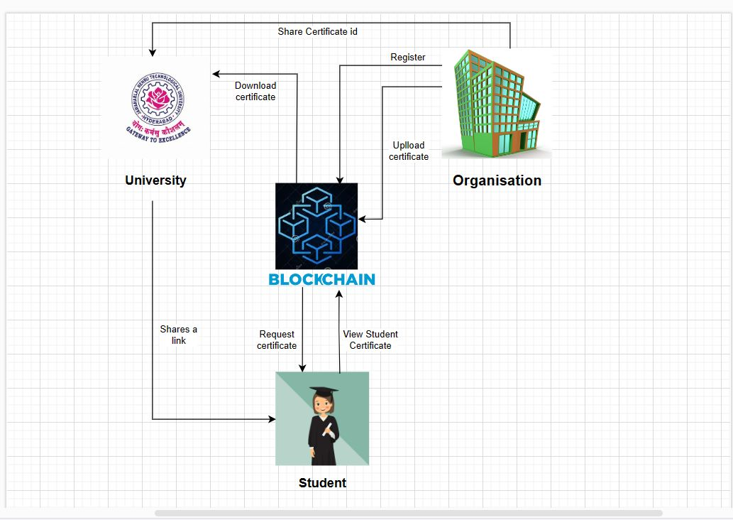

5.Pseudo code:

// Step 1: Certificate Issuance

certificate {

student: "ramya";

DOB: "2000-01-01";

otherDetails: "...";

hash: generateHash(certificate) // generate unique hash for the certificate

}

// Step 2: Verification Process

function verifyCertificate(certificate) {

// search for the hash of the certificate on the blockchain

if (blockchain.search(certificate.hash)) {

return true; // certificate is authentic

} else {

return false; // certificate is fraudulent

}

}

//step 3:Student accessing process

Function viewCertificate(certificate){

If authenticate user

Return true

Else

Return failed access

}

// student can view certificate in blockchain

Function downloadCertificate(certificate){

//student can download the certificate from the blockchain

function shareCertificate(certificate){

//student can share the certificate from the block chain

}

}